**Introduction:**

This page will give instructions on how to build the Prototype lab flow. This project was built and designed by Kenneth Mendoza, Sukhdeep Seehera and Myself (Matheus Almeida). By replicating our instructions, user should be able to replicate our end result as well.

**System Diagram:**

**Scanning and exiting the crib**

**Parts crib & PI**

**User**

User enters data on the Data goes to the pars crib where the User arrives and item is scanned out or upon

App requiring certain equipment PI is running the database. return and assigned to user who requested it

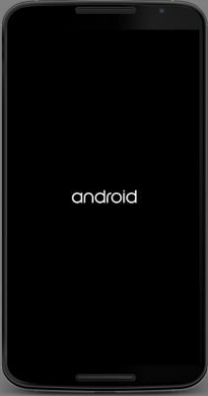 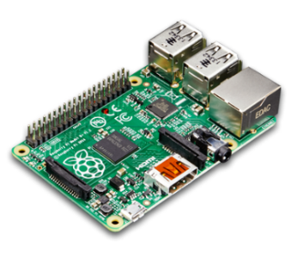 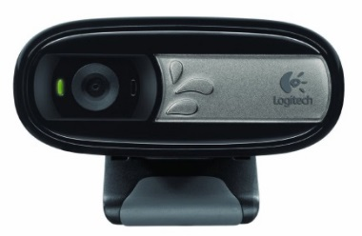

Once database is checked for availability, Scanning is done with the webcam running on the PI

User is informed that item is ready for pick up

**Budget:**

Our project is fairly simple on the hardware side, but the user is required to have access to a network and to have an HDMI display, a mouse and a keyboard to set up and use the raspberry PI.

Raspberry PI 3 kit - $101.69

Logitech c170 webcam - $34.61

PCB – provided by humber

**Time Commitment:**

Our project was completed throughout our 5th semester and took us some time to figure out how to scan the items properly and efficiently. That being said, it is not a lengthy project on our hardware side since the camera has no conflicts with the PI nor does the PCB. It will take more time coding.

Mechanical Assembly:

Once you acquired the raspberry pi 3, you will have to set it up.

You will need:

* Raspberry pi 3 starter bundle
* Mouse and keyboard
* HDMI display
* Internet access

1. Insert the pre-programmed microSD card into the microSD slot on the PI. It is located underneath it.

2. Connect mouse and keyboard on the USB ports

3. Connect it to the HDMI display, using the HDMI cable provided

4. Connect it to the internet either using and Ethernet cable or wirelessly

5. Power the PI up

6. Select language, keyboard and install

7. Once installing is over PI is ready to use

8. Now you will need to open the terminal and update and upgrade the pi in order for it to function properly with this project.

First type the command – sudo apt-get update

This is going to update the pi to its most recent version. Once it is done you will need to upgrade it

Command to upgrade – sudo apt-get upgrade

The upgrade may take around 30min and requires connectivity to the internet throughout the entire process.

10. Plug in the camera through the USB port

**PCB Soldering:**

The modular sensor hat was provided by humber. We had to modify by adding our names to it and once it was done, we sent it to the prototype lab where it was printed. Soldering was somewhat simple even though I didn’t have any previous experience with soldering. Took me about 3 hours to solder everything and around 30 minutes to test it.

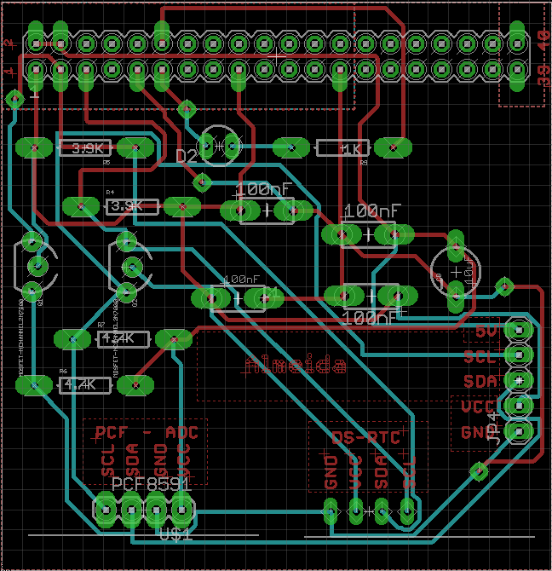

**Power up:**

The power up is fairly simple:

1. Turn on the PI with its power supply and an HDMI display
2. Plug in the camera on the PI through the USB port
3. Download the files exit.sh, test.py and scanner.sh on the PI
4. Connect the PCB to the PI
5. Run ./scanner.sh on the terminal
6. The program is going to run and open zbar. Scan the QR code and once it is successfully scanned a .txt file will be created with the QR information.

**Unit testing:**

First checked if the webcam is compatible by installing FSWEBCAM. Type: sudo apt-get install fswebcam on the pi’s terminal to install it. Once completed run the program by typing: fswebcam image.jpg. If the camera is compatible it should open and take a picture.

Secondly check if the LEDs on the PCB are working properly by running the file test.py. If it works the led should blink in the color red.

**Product Testing:**

After powering up run the shell script ./scanner.sh which is going to run test.py and exit.sh. It is then going to open the zbar library where you will scan your QR code. Once scanned it will create a .txt file with the QR info. Every time you want to scan a QR you have to re run the program since it is easy for our testing purposes at the moment. Test with multiple QRs to test its capabilities.